Emanuel Strauss
Benny Tsai
James Zarfoss

Agent-Based Simulations – Assignment 1 (Schelling Model Extension)

1. Create a metric for determining the degree of segregation in a population of agents.

We consider a single agent to be segregated if and only if it does not touch any agent of opposite color. This is determined by checking to see if an agent’s neighbor ratio is 1.

In order to find a general segregation value (between 0 and 1) for the entire world, we take the average segregation value {0,1} of all agents.

In cases where there are available blank spaces to allow each and every agent to be segregated, the possible segregation falls in the range between 0 and 1, inclusive.

However, there are cases where the necessary blank spaces are not available to allow a complete segregation (a global segregation value of 1), as some agents will be forced to reside next to an opposing color.

In order to deal with this, we created a normalizing metric which works as follows: First we determine the smallest dimension of the map (height or width). We then compare this length with the number of blank spaces available. If the amount of blank spaces exceeds this minLength, then by default, the maximum segregation is one where no blue agents touch any red agents (and visa versa). The normalization factor here is simply 1. Otherwise at the very least, there will be (minLength - blanks) red agents touching blue agents, and their equivalent blue agents touching the red agents. This makes for exactly 2*(minLength – blanks) non-segregated agents at absolute minimum. We then use this number to generate the normalizing factor.

Pulled from code, our max segregation normalization value is formed as follows:

- (double) getMaxSeg {
int numWhite = (worldXSize * worldYSize) - (numRedInhabitants + numBlueInhabitants);

if (numWhite > min(worldXSize, worldYSize)) return 1.0;
else return (1 - (2*(min(worldXSize, worldYSize) - numWhite ) / (numRedInhabitants + numBlueInhabitants)));
}

This ensures that our global segregation value can potentially fall within the full range of 0 and 1, and not merely some subset thereof. This allows for a consistent metric, regardless of map size, blank spaces, and other variables.

2. Study of how the degree of segregation (as measured by our metric) is affected by the preference percentage p of the agents. (We generally refer to p as the Happiness Threshold in this paper.)

The graph below shows how segregation changes with changes in p.

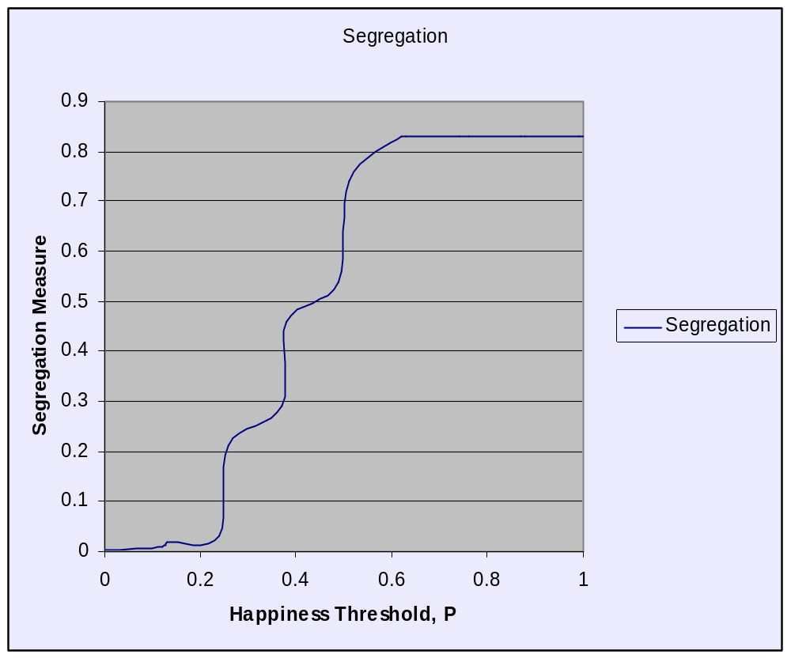

As you can see, the change in segregation is not exactly a step-function, but there are certainly regular and abrupt changes. These sudden increases in segregation are undoubtedly due to the 1/8th neighborhood thresholds. (Since each agent may have 8 neighbors, all neighborhood thresholds will be in increments of 1/8th. As p crosses thresholds marked by increments of 1/8th, the segregation can be seen to rise very sharply in the graph.) The segregation measure seems to max-out well before the threshold is set to 1, but we suspect this is due to the fact that the model never seems to reach the highest theoretically possible segregation – the map split into two halves, one red and one blue.

**Trials run with 1200 blue, 1200 red agents in a 50x50 world.
3. Create a variation of the Schelling Model and explore the impact of this variation on the degree of segregation.

For our variation, we gave the agents the ability to adapt to their environment. This capacity to adapt is implemented through a dynamic happiness threshold.

In order to accommodate this variation, we added three new adjustable variables for the agents. These variables (in no particular order) are:

maxHappiness: The maximum happiness threshold possible for any given agent.
minHappiness: The minimum happiness threshold possible for any given agent.
adaptability: The rate at which an agent will change its happiness threshold.

The exact amount of change for a given round is determined by comparing the agent’s current neighbor ratio with its current happiness threshold. The agent will then adapt its happiness threshold to better fit its environment. The exact value of the change is determined by the formula:

difference = currentRatio - happinessThreshold; //can be + or -
newThreshold = happinessThreshold + difference * adaptability;

Where adaptability can be configured beforehand. Also, note that the newThreshold will not cross the boundaries defined by maxHappiness and minHappiness.

The effect of this change is that an agent surrounded by its own kind will progressively become less and less tolerant of agents of other colors. On the other hand, an agent in the midst of opposing agents will become progressively more tolerant (by lowering its happiness threshold).

In order to better illustrate the differences in happiness thresholds, we created a slightly modified color scheme. Each agent (regardless of color) is grouped into one of three categories based on their happiness threshold in relation to the preset max and min thresholds:

Dark Color: Agent falls into the lowest 1/3 of happiness threshold range
Regular Color: Agent falls into the middle 1/3 of happiness threshold range
Bright Color: Agent falls into the highest 1/3 of happiness threshold range

At any rate, we believe this change very much reflects real-life. Generally, persons who spend a great deal of time surrounded by those of another group will grow to be more accepting. Conversely, those that spend most of their time surrounded by those of the same group usually do not interact as well with other groups. Furthermore, we can consider each “turn” to be the passing into a new generation. Children that grow up in close proximity to other ethnicities can be expected to be somewhat more tolerant than children who live a very cloistered life.
4. Report on your results.

Initially, we thought that introducing adaptability should decrease segregation in all situations, since agents can now adapt their happinessThreshold to their surroundings, meaning it’s possible for an agent to lower its happinessThreshold. To investigate the effects that various values of adaptability might have on the population’s behavior, we ran several test sets, with adaptability set to 0.01, 0.1, 0.5, and 1.0. Each test set consisted of different settings for minHappiness, maxHappiness, and initial happinessThreshold values. When adaptability is low (<0.1), the population’s behavior conformed fairly closely to the default model. However, a moderate amount of adaptability (>0.1) introduced a high degree of divergence from the default model. At moderate to high adaptability, the population converged to a high degree of segregation regardless of the initial happinessThreshold setting. Interestingly, we observed mingling of agents for the first time at an adaptability value of 1.0. Intuitively this makes sense: it is only when agents immediately adapt to their surroundings that mingling can take place. However, even a small amount of migration will trigger a cascading spread of increasing segregation. Since the motion algorithm is designed to only increase segregation, never maintain a lower segregation (no agent moves to another neighborhood with more neighbors of the opposite color), adaptability more often serves to accelerate the increase of segregation rather than lower it.

We also noticed that the range of possible happinessThreshold values as defined by minHappiness and maxHappiness had a consistent effect across all adaptability values. The effects of minHappiness were most noticeable with a high adaptability, where mingling of agents is possible. MinHappiness higher than 0.125 has the effect of negating the possibility of mingling. Conversely, lowering maxHappiness from 1.0 serves to decrease segregation. As the interval defined by minHappiness and maxHappiness decreases, the time taken to converge to a final segregation value shortens, since there is less distance from the initial value to the final possible values.

